Cluster Omega Analysis Report
Sequence Homology Analysis of Human Proto-Oncogene Tyrosine -Protein Kinase ABL1 (BCR-ABL Target Protein)
Code Alpha Bioinformatics Internship- Task2- Sequence Conservation and Structural Interpretation

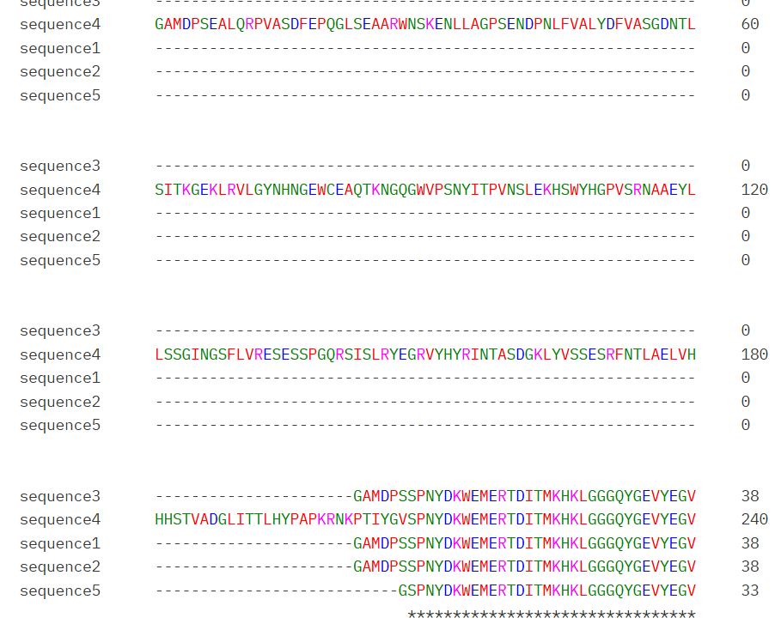
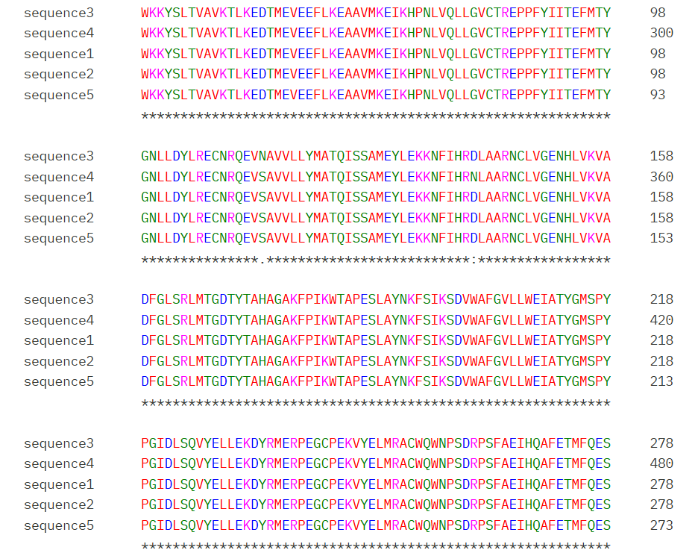
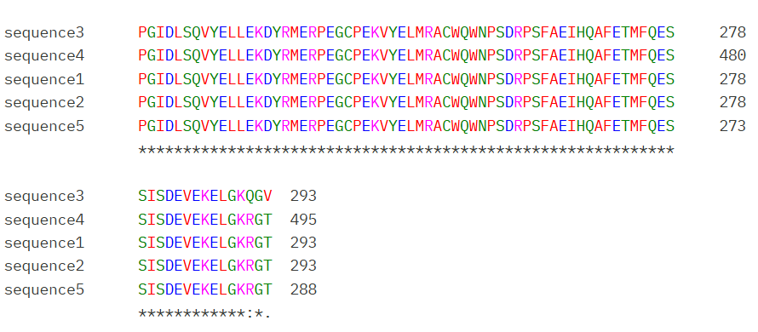
Fig.2.Cluster Omega Analysis (1IEP, 1FPU, 2E2B, 1OPQ and 2QOH)
Multiple Sequences Alignment of CML structure 1IEP, 1FPU, 2E2B, 1OPQ and 2QOH was performed using Cluster Omega to analysis conservation and structure similarity. It is observed that extensive conservation across five sequences. This is indicated by the large number of identical residues marked by asterisks (*).

The C-terminal kinase domain segment (PGIDLSQVYELLEKDYRMERPEGCPEKVYELMRACWQWNPSDRPSFAEIHQAFETMFQES) is fully conserved across all five structures without a single mismatch, confirming that this region — which includes key catalytic residues — is structurally and functionally invariant across different crystal forms and species. A minor variation is observed only in the final residues, where sequence3 shows KQGV compared to KRGT in sequence1, sequence2, sequence4, and sequence5, representing a small isoform- or construct-specific difference at the extreme C-terminus rather than a functionally significant change.
Sequence4 (1OPK, full-length: 495 residues) is notably longer than the other four structures (each ~273–293 residues), as it includes additional N-terminal regulatory sequence beyond the isolated kinase catalytic domain. Despite this length difference, the aligned kinase domain region remains identical to the shorter constructs, reinforcing that the core catalytic architecture is preserved regardless of which regulatory domains are present in the crystallized construct.

